CHAPTER 41
ATOMIC STRUCTURE
Discussion Questions

Q41.1 The probability is given by 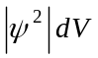, where 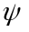is the wave function. 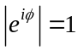 so the two wave functions give the same probability.

Q41.2 The Bohr model and the Schrodinger analysis yield the same expression for the energy levels (Eq.(41.21)). The Bohr model says the angular momentum of an electron in energy state n is 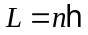. The Schrodinger analysis says 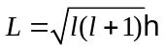, where 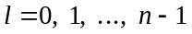. Therefore the two approaches give quite different results for the angular momentum. The Schrodinger analysis says 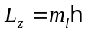, with 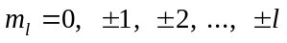, so 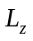 is quantized and the possible orientations of are restricted (Fig.41.6). In the Bohr model the electron travels in an orbit of definite radius whereas in the Schrodinger analysis the location of the electron is determined by a position probability distribution (Fig.41.8).

Q41.3 Yes, in principle. But the spacing between allowed orbits is exceedingly small and the quantization of the orbits is not observable. (See Discussion Question 39.11.)

Q41.4 The electrons exert forces on each other so their motions are correlated.

Q41.5 For ionized atoms the magnetic force on the net charge would overwhelm the force due to the spin magnetic moment.

Q41.6 (a) Yes, , with . Except for 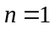 there are two or more l values for each n. For example, for 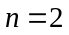 the value of l can be 1 or 0. (b) Yes. A given value of l can correspond to any value of n, for 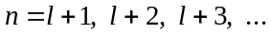. For example, 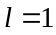 can have 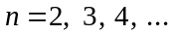.

Q41.7 A homogeneous field exerts zero net force on a current loop (Section 27.7).

Q41.8 The Pauli exclusion principle requires that no two electrons have the same set of quantum numbers. They have the same , , and 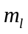, so they must have different 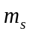 values.

Q41.9 Eq.(27.27) says that the interaction energy is minimum when a dipole is in a direction parallel to the field direction and a maximum when the dipole direction is opposite to the field. The 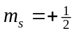 state has 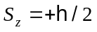 and by Eq.(41.38) its spin magnetic moment is in the -direction. So for this state and 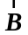 are antiparallel and the interaction energy between the spin magnetic moment and the field is a maximum. The 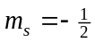 state has 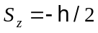 and its spin magnetic moment is in the -direction. For this state and are parallel and the interaction energy is a minimum. The state has lower energy.

Q41.10 In an alkali metal there is a single electron outside filled shells. The electron density in the filled shells is at a smaller radius than for the electron outside the filled shells. This reduces the correlation of the motion of the outermost electron with that of the rest of the electrons. For the transition metals there are two or more electrons outside of filled shells. These electrons occupy similar regions of space and their motion is highly correlated.

Q41.11 The 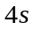 level lies below the 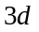 level. Lower levels fill first in building up the ground states of atoms.

Q41.12 Example 21.1 showed that the electrical force between two alpha particles is immensely larger than the gravitational force between them. The same holds true for an electron and a nucleus; the gravitational force is totally insignificant in atomic structure.

Q41.13 They all have a 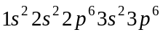 core plus some number of and electrons. The chemical properties do not depend much on how many and electrons there are in the atom.

Q41.14 Zinc (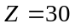) has filled subshells through 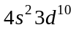. The next lower energy orbital is the 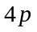 so the neutral gallium atom has a electron outside a zinc configuration core. Ga has the same electron configuration as zinc. Ga has a 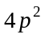 configuration outside a zinc configuration core.

Q41.15 For example, without spin helium would have an electron configuration of 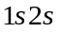and would not be chemically inert. The periodic table indicates double filling of each , , and sublevel and this requires a fourth quantum number since the Pauli exclusion principle doesn’t allow two electrons with the same set of quantum numbers.

Q41.16 The orbital motion of the electrons results in a magnetic field that is internal to the atom.

Q41.17 In the alkali atoms there is one electron outside filled shells. The electron density in the filled shells is at smaller radius than the outer electron so the electrons in the filled shells are effective in screening the nuclear charge. The outer electron sees an effective nuclear charge of close to 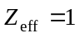. In a noble gas there are several electrons in the same shell and therefore in the same region of space. These electrons only partially screen the nuclear charge from each other and 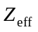 is larger than 1.

Q41.18 The ionization potential is 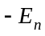, where 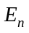is the level energy of the least tightly bound electron. The level energy is given by Eq.(41.45) and depends on the quantum number for the level and the effective nuclear charge 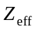seen by the electron. is less than because of partial screening of the nucleus by the other electrons in the atom. As electrons are removed, for the outermost electron the screening of the nucleus by the other electrons decreases. For a given the ionization potential decreases when decreases. The ground state electron configuration of magnesium is 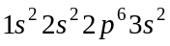. For a 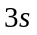electron the other electrons screen the nucleus and is approximately unity. For 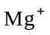the ground state electron configuration is 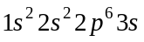 and 10 inner electrons screen the nucleus from the 3d electron and is approximately 2. For 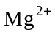 the ground state electron configuration is 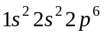. The screening for an outermost electron is further reduced. And now it is a rather than a 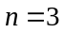 electron that will be removed in ionization and this further increases the ionization potential.

Q41.19 The effect on an electron of all the other electrons is approximated in an average way by a spherically symmetric potential energy function. In reality the interaction between any pair of electrons depends on the instantaneous location of the two electrons and the electron motions are correlated. The central field approximation is a simplified treatment of the electron-electron interaction.

Q41.20 There is little screening for a 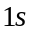 electron in gold except for the screening from the other electron so the electron has 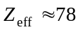. Eq.(41.45) says the energies scale by 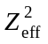. So the energy for gold is about 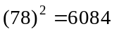 times larger than the energy for hydrogen. It takes 13.6 eV to remove the electron from hydrogen. A photon with 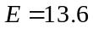 eV has wavelength 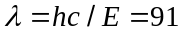 nm. The photon is in the ultraviolet. It takes about 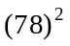(13.6 eV) = 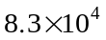 eV to remove a electron from gold. A photon with 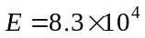 eV has wavelength 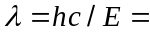 (91 nm)/(78) = 0.015 nm. This photon is a hard x ray.

Q41.21 (a) 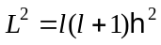. 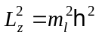. The maximum value of 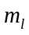 is l so the maximum 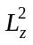 is given by 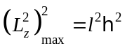 . 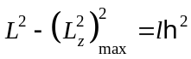. 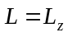 only when 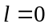. For 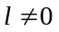, 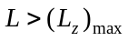. (b) A classical object can have even when L is not zero, if is in the z-direction.

Q41.22 No. At the absorption edge the transition of the electron in the atom is from the level to the lowest unfilled bound sublevel of the atom. All electrons in the atom are still bound. However, when the hole in the orbital is filled by an outer-shell electron, the energy released can either result in the emission of an x ray or in the ionization of one of the electrons.
Q41.23 No. Hydrogen cannot emit photons of energy greater than 13.6 eV. A photon with this energy has wavelength nm. This photon is in the ultraviolet and does not have enough energy to be an x ray.
Q41.24 For either electron the possible results of a measurement of 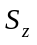 are 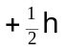 or 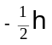. For either electron the probability of each result is . If measurement of for electron 1 yields the value , then the wavefunction collapses to 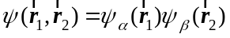 and a measurement of for electron 2 gives a result with unit probability.

Q41.25 For either electron a measurement of yields the value with unit probability. If measurement of for electron 1 yields the value of then a measurement of for electron 2 yields a value of with unit probability.

